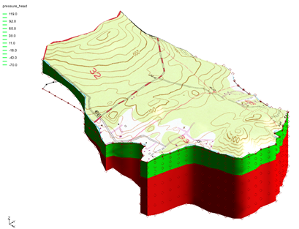

GMS 10.9

GMS 10.9 Tutorial

FEMWATER – Flow Model

Build a FEMWATER model to simulate flow

Objectives

This tutorial shows how to build a 3D mesh and a FEMWATER flow model using the conceptual model approach. It will also review running the model and examining the results.

Time

* 45–65 minutes

Required Components

* GMS Core
* FEMWATER
* Geostatistics
* Mesh
* Subsurface

Prerequisite Tutorials

* Feature Objects
* Geostatistics 2D
* Stratigraphy Modeling – TINs

|  |
| --- |
| [1 Introduction 2](#_Toc133311337)  [1.1 Getting Started 3](#_Toc133311338)  [2 Building the Conceptual Model 3](#_Toc133311339)  [2.1 Importing the Background Image 3](#_Toc133311340)  [2.2 Saving with a New Name 4](#_Toc133311341)  [2.3 Define the Units 4](#_Toc133311342)  [2.4 Initializing the FEMWATER Coverage 4](#_Toc133311343)  [2.5 Creating the Boundary Arcs 4](#_Toc133311344)  [2.6 Redistributing the Arc Vertices 6](#_Toc133311345)  [2.7 Defining the Boundary Conditions 6](#_Toc133311346)  [2.8 Building the Polygon 6](#_Toc133311347)  [2.9 Assigning the Recharge 7](#_Toc133311348)  [2.10 Creating the Wells 7](#_Toc133311349)  [3 Building the 3D Mesh 8](#_Toc133311350)  [3.1 Defining the Materials 8](#_Toc133311351)  [3.2 Building the 2D Projection Mesh 9](#_Toc133311352)  [3.3 Building the TINS 9](#_Toc133311353)  [3.4 Interpolating the Terrain Data 10](#_Toc133311354)  [3.5 Interpolating the Layer Elevation Data 11](#_Toc133311355)  [3.6 Interpolating the Layer Elevation Data 12](#_Toc133311356)  [4 Converting the Conceptual Model 13](#_Toc133311357)  [5 Selecting the Analysis Options 14](#_Toc133311358)  [5.1 Entering the Run Options 14](#_Toc133311359)  [5.2 Setting the Iteration Parameters 15](#_Toc133311360)  [5.3 Selecting Output Control 15](#_Toc133311361)  [5.4 Defining the Fluid Properties 15](#_Toc133311362)  [6 Defining Initial Conditions 16](#_Toc133311363)  [6.1 Digitizing the Scatter Point Set 16](#_Toc133311364)  [6.2 Creating the Dataset 17](#_Toc133311365)  [7 Defining the Material Properties 18](#_Toc133311366)  [8 Saving and Running the Model 19](#_Toc133311367)  [9 Viewing the Solution 19](#_Toc133311368)  [9.1 Viewing Head Contours 19](#_Toc133311369)  [9.2 Viewing a Water Table Isosurface 20](#_Toc133311370)  [9.3 Draping the TIFF Image on the Ground Surface 21](#_Toc133311371)  [10 Conclusion 23](#_Toc133311372) |

# Introduction

FEMWATER is a three-dimensional finite element groundwater model designed for simulating both flow and transport in saturated and unsaturated zones. It can also simulate coupled flow and transport to address density-dependent problems, such as salinity intrusion. This tutorial demonstrates how to build a steady-state FEMWATER model to simulate flow only.

This tutorial focuses on modeling a small coastal aquifer site, which contains three production wells, each pumping at a rate of 2,830 m3/day (Figure 1). The model features two no-flow boundaries: one on the upper left, representing a parallel flow boundary, and another on the left, where a high bedrock elevation causes the aquifer to thin. A stream at the lower left provides a specified head boundary, while the coastal boundary is represented by a specified head condition. The coastline arc is assigned a specified concentration boundary of 19 mg/liter of salt.

The site’s stratigraphy consists of an upper and lower aquifer. The upper aquifer has a hydraulic conductivity of 3 m/day, while the lower aquifer has a hydraulic conductivity of 9 m/day. The wells extend into the lower aquifer. Recharge to the aquifer occurs at a rate of about one foot per year.

This tutorial demonstrates and discusses the following:

* Importing a background image
* Defining coverages and mapping them to a 2D mesh
* Creating TINs from the mesh
* Interpolating elevations from scatter points to TINs
* Building a 3D mesh from the TIN horizons
* Mapping the conceptual model to a FEMWATER simulation
* Defining additional conditions and running FEMWATER
* Viewing the water table as an isosurface
* Draping the TIFF image on the ground surface

## Getting Started

Do the following to get started:

1. If GMS is not running, launch GMS.
2. If GMS is already running, select *File* | **New** to restore the program settings to the default state.
3. If a dialog appears asking to save changes, click **Don’t Save** to clear all data. The Graphics Window of GMS should refresh to show an empty space

# Building the Conceptual Model

FEMWATER models can be developed using either the direct approach or the conceptual model approach. With the direct approach, a mesh is manually constructed, and boundary conditions are assigned directly to the mesh by interactively selecting nodes and elements. With the conceptual model approach, feature objects—such as points, arcs, and polygons—are used to define the model domain and boundary conditions. The mesh is then automatically generated, and the boundary conditions are automatically assigned based on the defined features. This tutorial uses the conceptual model approach.

## Importing the Background Image

Before creating the feature objects, import a scanned image of the site. This image was produced by scanning a section of a USGS quadrangle map using a desktop scanner. It was previously imported into GMS and registered to real-world coordinates. The registered image was then saved as a part of a GMS project file.

Do the following to import the image:

1. Click **Open** File:Open Macro.svg to bring up the *Open* dialog.
2. Select “Project Files (\*.gpr)” from the *Files of type* drop-down.
3. Browse to the \*femwater\femwater* directory for this tutorial and select “start.gpr”.
4. Click **Open** to import the project file and close the *Open* dialog.

## Saving with a New Name

Create a new project by saving it with a new name:

1. Select *File* | **Save As…** to bring up the *Save As* dialog.
2. Select “Project Files (\*.gpr)” from the *Save as type* drop-down.
3. Enter “femmod.gpr” as the *File name*.
4. Click **Save** to create the new project file and close the *Save As* dialog.

It is recommended to **Save** File:Save Macro.svg periodically throughout the tutorial.

## Define the Units

Next, define the units. The selected units are used by GMS to display informative labels alongside input fields.

1. Select *Edit* | **Units…** to bring up the *Units* dialog.
2. From the *Time* drop-down, select “d” (days).
3. From the *Mass* drop-down, select “kg” (kilograms).

The remaining units are for a transport simulation and can be ignored.

1. Click **OK** to exit the *Units* dialog.

## Initializing the FEMWATER Coverage

Before creating the feature objects, first create a FEMWATER coverage.

1. In the Project Explorer, right-click on the empty space and select *New* | **Conceptual Model…** to open the *Conceptual Model Properties* dialog.
2. Enter “femmod” as the *Name*.
3. From the *Type* drop-down, select “FEMWATER”.
4. Click **OK** to close the *Conceptual Model Properties* dialog.
5. Right-click on the new “File:Conceptual Model Icon.svg femmod” conceptual model and select **New Coverage…** to open the *Coverage Setup* dialog.
6. Enter “femwater” as the *Coverage name*.
7. In the *Sources/Sinks/BCs* column, turn on *Flow BC*, *Wells*, and *Refinement*.
8. In the *Areal Properties* column, turn on *Meshing options*.
9. Click **OK** to close the *Coverage Setup* dialog.

## Creating the Boundary Arcs

At this stage, begin creating the arcs that define the model boundary. As shown in Figure 1, the three boundaries on the left are marked on the background image and are color-coded for reference.

1. Select the “Coverage – active femwater” coverage to make it active.
2. Using the **Create Arc** File:GMS Create Arc Tool.svg tool, click to place a series of vertices along the black line, double-clicking to end the arc (black line in Figure 1).
3. Click to place a series of vertices along the red line, double-clicking to end the arc (red line in Figure 1).

Make sure that the arcs are connected by starting precisely at the ending point of the previous arc.

1. Click to place a series of vertices along the blue line, double-clicking to end the arc (blue line in Figure 1).

Again, make sure that the arcs are connected

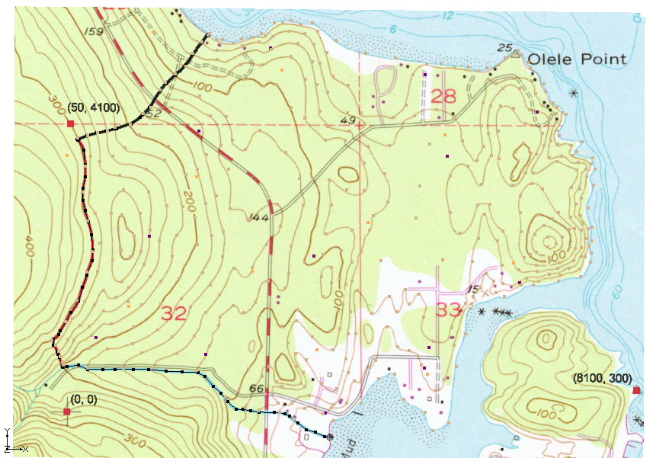

**Blue line**

**Black line**

**Red line**

Figure 1 First three boundary arcs

1. Create an arc for the coastline boundary (between the arrows in Figure 2).

Once again, be sure that the arc is connected to the other boundary arcs.

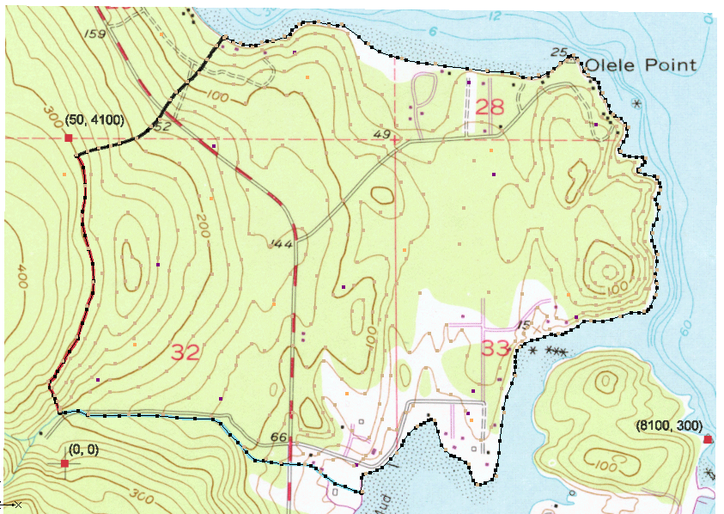

Figure 2 Coastline boundary arc

## Redistributing the Arc Vertices

The two endpoints of each arc are referred to as “nodes”, while the intermediate points are called “vertices”. These arcs will later be used to generate a 2D, which will then be converted into a 3D mesh. The spacing of the line segments defined by the vertices determines the size and number of mesh elements. To ensure even spacing and appropriate segment lengths, redistribute the vertices along each arc.

1. Using the **Select Arcs**File:GMS Select Arc Tool.svg tool, select all four arcs by dragging a box that encloses all of the arcs.
2. Select *Feature Objects |* **Redistribute Vertices…** to open the *Redistribute Vertices* dialog.
3. Enter “90.00” for the *Average spacing.*
4. Click **OK** to close the *Redistribute Vertices* dialog and redistribute the vertices.

## Defining the Boundary Conditions

With the arcs defined, assign boundary conditions to them. The two no-flow boundaries require no changes, as the default boundary type is no-flow. However, the stream arc and the coastline arc must be designated as constant-head boundaries.

1. Using the **Select Arcs** File:GMS Select Arc Tool.svg tool, hold down the *Shift* key and select the coastline arc and the stream arc (the blue one in Figure 1).
2. Click the **Properties** File:GMS Properties Macro.svg macro to open the *Attribute Table* dialog.
3. In the *All* row in the spreadsheet, select “spec. head” from the *Flow bc* column drop-down to assign this to both arcs.
4. Click **OK** to close the *Attribute Table* dialog.

Head values are not assigned directly to arcs, but rather to the nodes at each end. This approach allows the head to vary linearly along the arc. For the coastline arc, both endpoints share the same head value. Since the default head value is zero, no changes need to be made. However, the head value must be specified for the upperstream (inland) end of the stream arc. The head will then decrease linearly along the stream, from the specified inland value to zero at the coast.

1. Using the **Select Points\Nodes** File:GMS Select Node Tool.svg tool, double-click on the inland node of the stream arc to bring up the *Attribute Table* dialog.
2. On the “spec. head” row, enter “60.0” in the *Head (m)* column.
3. Click **OK** to close the *Attribute Table* dialog.

## Building the Polygon

With the arcs defined, create a polygon to represent the model domain. This polygon is essential for defining the domain during mesh generation and for assigning recharge. In many cases, the model domain is divided into multiple recharge zones, each defined by a polygon. However, for this model, only one polygon is needed, as a single recharge value is applied throughout.

1. Select *Feature Objects |* **Build Polygons**.
2. To view the polygon area, use the **Select Polygons** File:GMS Select Polygon Tool.svg tool to click on the center of the new polygon.

The Graphics Window should appear similar to Figure 3.

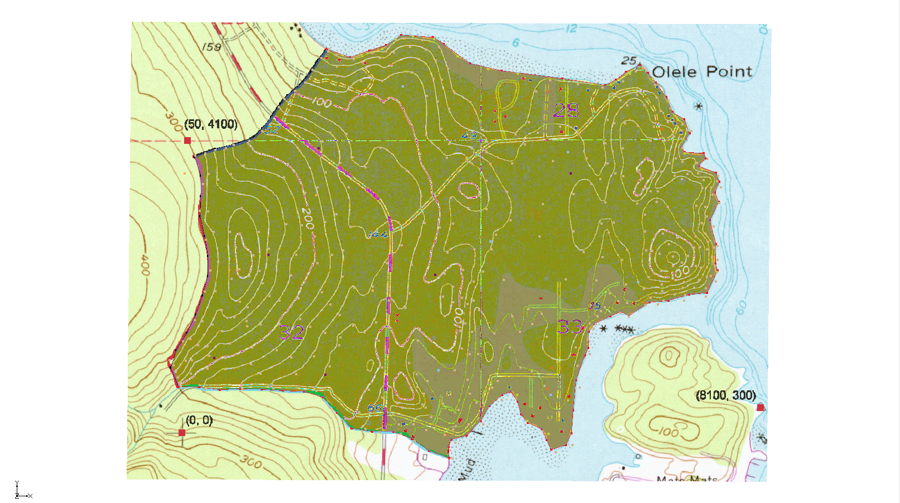

Figure 3 The polygon defining the model domain

## Assigning the Recharge

Next, assign the recharge value. In FEMWATER, recharge can be applied using either a specified-flux boundary or a variable boundary. While the variable boundary offers greater accuracy, it is more time-consuming to set up and can be less stable. For the purposes of this tutorial, use the simpler and more stable specified-flux approach to ensure timely completion.

1. Using the **Select Polygons** 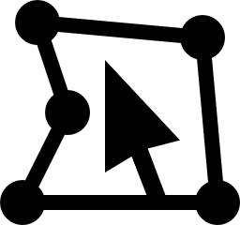 tool, double-click anywhere in the interior of the model domain to bring up the *Attribute Table* dialog.
2. From the *Flow bc* drop-down, select “spec. flux”.
3. Enter “0.0009” in the *Flux rate (m/d)* column.

This value is in “m/d” and corresponds to about 0.34 m/yr.

1. Click **OK** to close the *Attribute Table* dialog.
2. Click anywhere outside the polygon to deselect it.

## Creating the Wells

The final step in defining the conceptual model is to create the wells. In this case, it is necessary to create three wells.

To create the first well, do the following:

1. Using the **Create Point** File:Create Points Tool.svg tool, create a point anywhere in the upper-right corner of the model.
2. In the edit fields at the top of the Graphic Window, update the *XYZ* coordinates of the newly created point to “1612.0”, “1282.0”, and “14.0”, respectively.
3. With the point still selected, click the **Properties** File:GMS Properties Macro.svg macro to open the *Attribute Table* dialog.

A well point must be assigned the type “well”. Both the pumping rate and the elevation of the screened interval must be specified. The screened interval determines which 3D mesh nodes receive the pumping rate. The total pumping rate is distributed among all nodes within the interval. In this case, only one node falls within the screened interval.

1. Scroll to the right if necessary to see the additional columns in the spreadsheet.
2. In the spreadsheet, select “well” from the drop-down in the *Type* column.
3. Enter “-44.0” in the *Top scr.* column.
4. Enter “-55.0” in the *Bot. scr.* column.
5. Enter “-2830.0” in the *Flow rate (ft^3/d)* column.
6. Turn on *Refine*.

This refines the mesh around the well.

1. Enter “45.0” in the *Elem. size* column.

This controls the element size at the well.

1. Click **OK** to exit the *Attribute Table* dialog.
2. Repeat steps 1–11 to create the second and third wells with the properties given in the table below.

|  |  |  |  |  |  |  |  |  |  |  |  |  |  |  |  |  |  |  |  |  |  |  |  |  |
| --- | --- | --- | --- | --- | --- | --- | --- | --- | --- | --- | --- | --- | --- | --- | --- | --- | --- | --- | --- | --- | --- | --- | --- | --- |
| |  |  |  |  |  |  |  |  | | --- | --- | --- | --- | --- | --- | --- | --- | | Well | X | Y | Z | Top scr. | Bot. scr. | Flow rate (m^3/d) | Elem. size | | 2 | 1175.0 | 925.0 | 23.0 | -50.0 | -62.0 | -2830.0 | 45.0 | | 3 | 1532.0 | 571.0 | 14.0 | -75.0 | -90.0 | -2830.0 | 45.0 | |

# Building the 3D Mesh

At this stage, the conceptual model is complete and ready for use in generating the 3D finite-element mesh. The mesh will consist of two zones: one representing the upper aquifer and the other representing the lower aquifer.

To build the mesh, begin by creating a 2D “projection” mesh based on the feature objects in the conceptual model. Next, generate three triangulated irregular networks (TINs): one for the top (terrain) surface, one for the bottom of the upper aquifer, and one for the bottom of the lower aquifer. Finally, use the **Horizons → 3D Mesh** command to build the 3D elements from the TIN horizons.

## Defining the Materials

Before building the mesh, define a material for each aquifer. The materials will be assigned to the TINs and, subsequently, to the individual 3D mesh elements.

1. Select *Edit* | **Materials…** to bring up the *Materials* dialog.
2. In row *1*, enter “Upper Aquifer” in the *Name* column and press the *Tab* key.
3. Select *Green* from the drop-down in the *Color/Pattern* column.
4. In row *2* (marked with \* until this step is completed), create a new material by entering “Lower Aquifer” in the *Name* column, then press the *Tab* key.
5. Select *Red* from the drop-down in the *Color/Pattern* column.
6. Click **OK** to close the *Materials* dialog.

## Building the 2D Projection Mesh

The 2D projection mesh can be constructed directly from the conceptual model:

1. Select *Feature Objects |* **Map → 2D Mesh**.

After a few seconds, the mesh should appear (Figure 4).

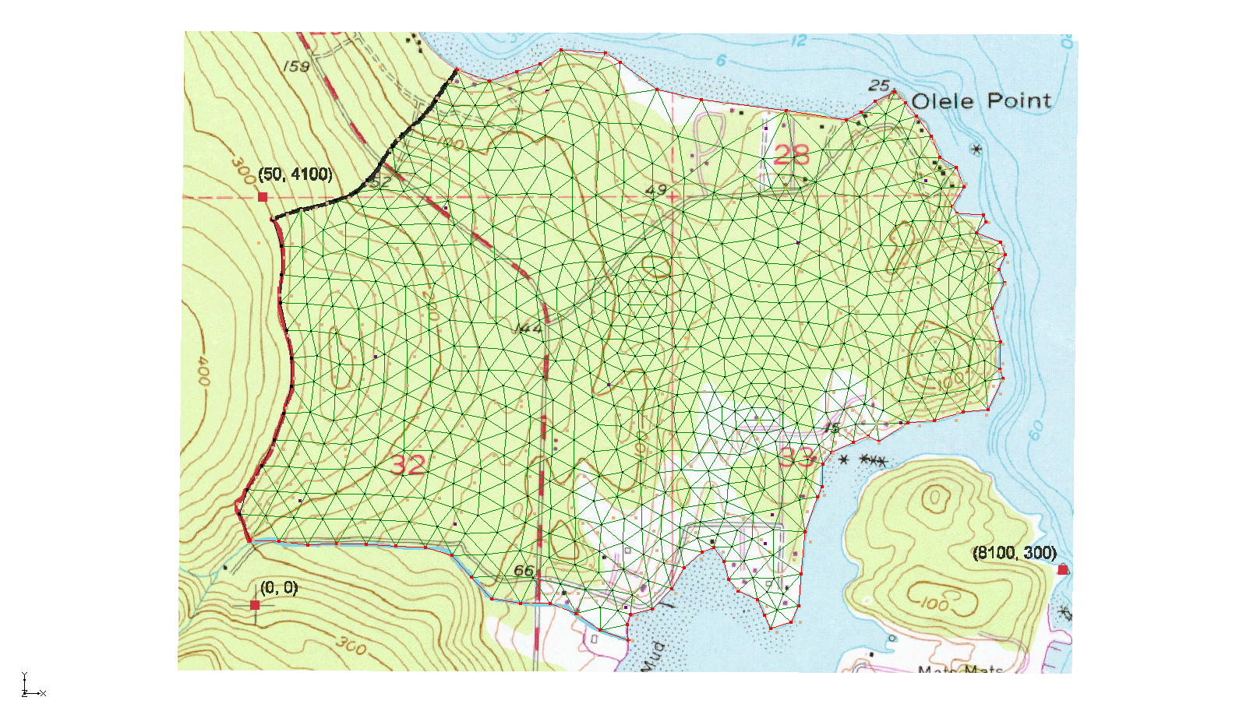

Figure 4 The 2D mesh

## Building the TINS

To define the stratigraphic horizons, create three TINs, each as a copy of the 2D mesh. Initally, all three TINs will share the same elevations values—set to zero—based on the 2D mesh. Once the TINs are created, interpolate the appropriate elevations to each TIN using a set of scatter points.

To create the top TIN:

1. Select the “File:2D Mesh Folder.svg 2D Mesh Data” folder in the Project Explorer to make it active.
2. Select *Mesh* | *Convert To*| **TIN** to open the *Properties* dialog.
3. For the *TIN name*, enter “terrain”.
4. From the *TIN material* drop-down, select “Upper Aquifer”.

This defines the material below the TIN.

1. For the *Horizon ID*, enter “2”.
2. Click **OK** to close the *Properties* dialog.

To create the second TIN:

1. Select *Mesh* | *Convert To*| **TIN** to open the *Properties* dialog.
2. For the *TIN name*, enter “bottom upper aquifer”.
3. From the *TIN material* drop-down, select “Lower Aquifer”.
4. For the Horizon ID, enter “1”.
5. Click **OK** to close the *Properties* dialog.

To create the third TIN:

1. Select *Mesh* | *Convert To*| **TIN** to open the *Properties* dialog.
2. For the *TIN name*, enter “bottom lower aquifer”.
3. From the *TIN material* drop-down, select “Lower Aquifer”.

This defines the material below the TIN.

1. For the *Horizon ID*, enter “0”.
2. Click **OK** to close the *Properties* dialog.

## Interpolating the Terrain Data

Next, use the scatter points representing terrain elevations to interpolate values to the top TIN. These terrain points were generated by digitizing elevations from the contour map. Before interpolating to the TIN, ensure that the top TIN is active and adjust the interpolation settings as needed, based on prior experience with this scatter point dataset.

1. From the Project Explorer, select the “File:TIN Module Icon.svgterrain” TIN.
2. Expand the “File:2D Scatter Folder.svg 2D Scatter Data” folder.
3. Select the “File:2D Scatter Icon.svg terrain” scatter point set to make it active.
4. Select *Interpolation* |**Interpolation Options…** to open the *2D Interpolation Options* dialog.
5. In the *Interpolation method* section, click **Options…** next to the *Inverse distance weighted* option to open the *2D IDW Interpolation Options* dialog.
6. In the *Nodal function* section, select *Constant (Shepard’s method)*.
7. Click **OK** to exit the *2D IDW Interpolation Options* dialog.
8. Click **OK** to exit the *2D Interpolation Options* dialog.

To interpolate from the scatter points to the TIN, do the following:

1. In the Project Explorer, right-click on the “File:2D Scatter Icon.svg terrain” scatter point set and select *Interpolate To |* **Active TIN** to bring up the *Interpolate → Object* dialog.
2. Click **OK** to accept the defaults and close the *Interpolate → Object* dialog.

The Graphics Window will appear as in Figure 5.

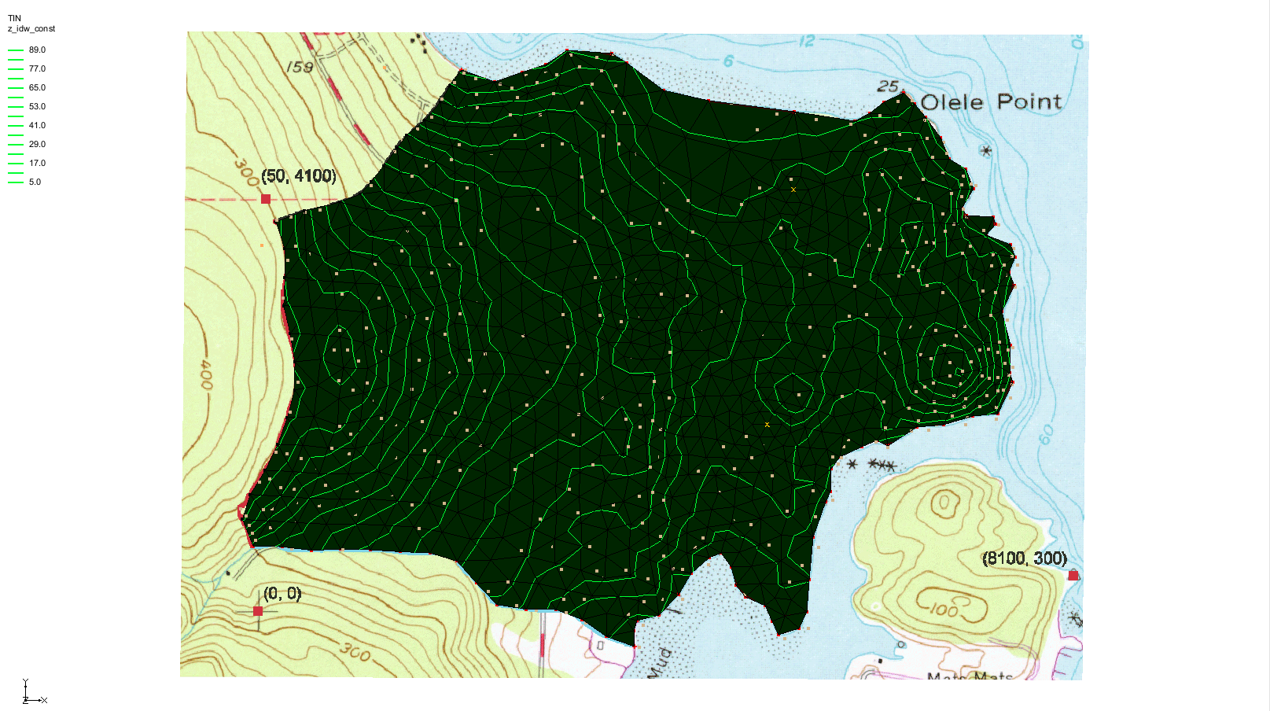

Figure 5 Terrain scatter data has been interpolated

To view the interpolated elevations:

1. Switch to **Oblique View** File:Oblique View Macro.svg.
2. Click the **Display Options**File:Display Options Macro.svg macro to bring up the *Display Options* dialog.
3. In the section below the list on the left, enter “4.0” for the *Z magnification.*
4. Click **OK** to close the *Display Options* dialog.

The Graphics Window should appear similar to Figure 6.

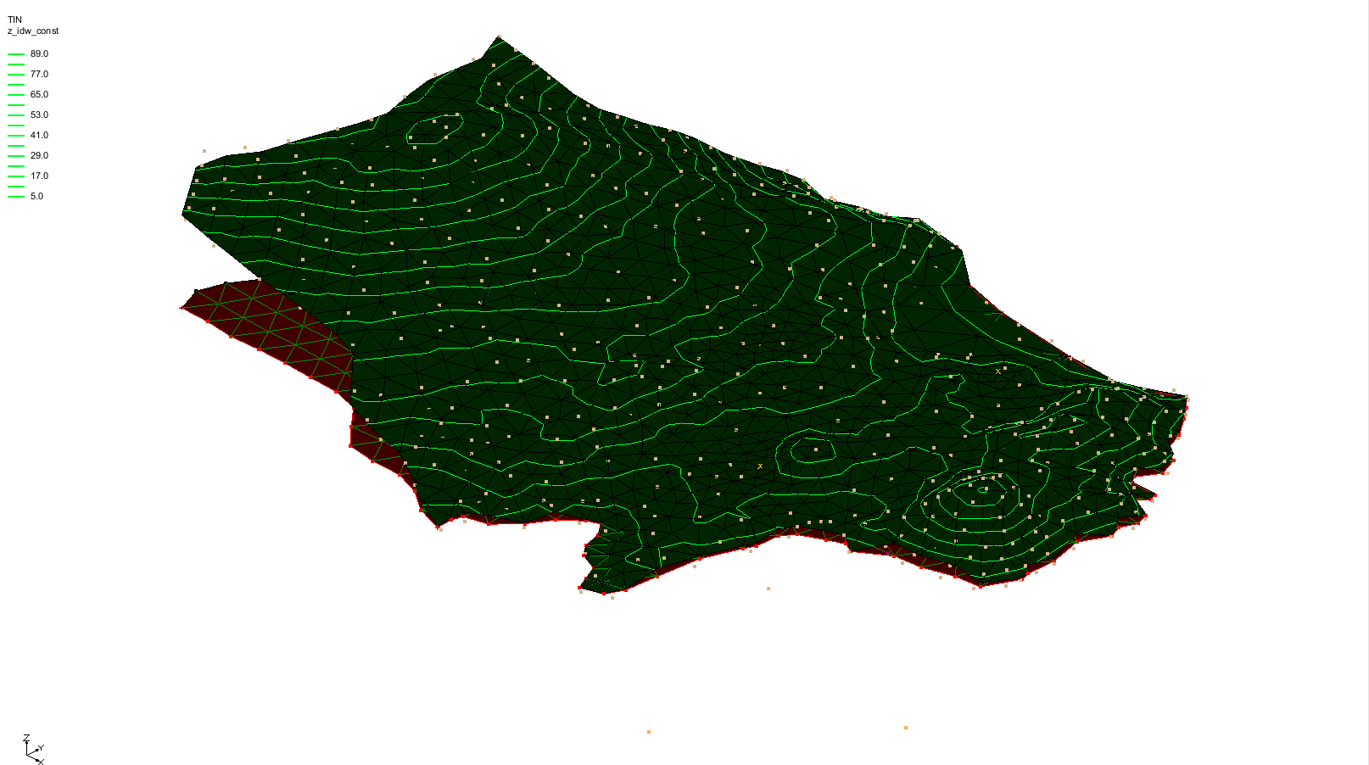

Figure 6 Oblique view showing elevations on the terrain TIN

## Interpolating the Layer Elevation Data

Next, interpolate the elevations that define the bottoms of the upper and lower aquifers. These elevations were derived from data collected through exploratory boreholes.

1. Select the “File:TIN Module Icon.svg bottom upper aquifer” TIN in the Project Explorer to make it active.
2. Expand the “File:2D Scatter Icon.svg elevs” dataset under “File:2D Scatter Folder.svg 2D Scatter Data” in the Project Explorer.

This dataset includes two elevation datasets: one for the bottom of the upper aquifer and one for the bottom of the lower aquifer. Begin by interpolating the elevations for the bottom of the upper aquifer.

1. Select the “File:Dataset Points Active.svg bot of layer 1”dataset to make it active.

To interpolate from the scatter points to the active TIN, do the following:

1. Right-click on the “File:2D Scatter Icon.svg elevs”scatter set and select *Interpolate To |* **Active TIN** to bring up the *Interpolate → Object* dialog.
2. Click **OK** to accept the defaults and close the *Interpolate → Object* dialog.

Finally, interpolate the elevations for the bottom TIN:

1. Select the “File:TIN Module Icon.svg bottom lower aquifer” TIN in the Project Explorer to make it active.
2. Select the “File:Dataset Points Active.svg bot of layer 2**”** dataset to make it active.
3. Right-click on the “File:2D Scatter Icon.svg elevs”scatter set and select *Interpolate To |* **Active TIN** to bring up the *Interpolate → Object* dialog.
4. Click **OK** to accept the defaults and close the *Interpolate → Object* dialog.

At this point, the correct elevations on all three TINs should be visible (Figure 7).

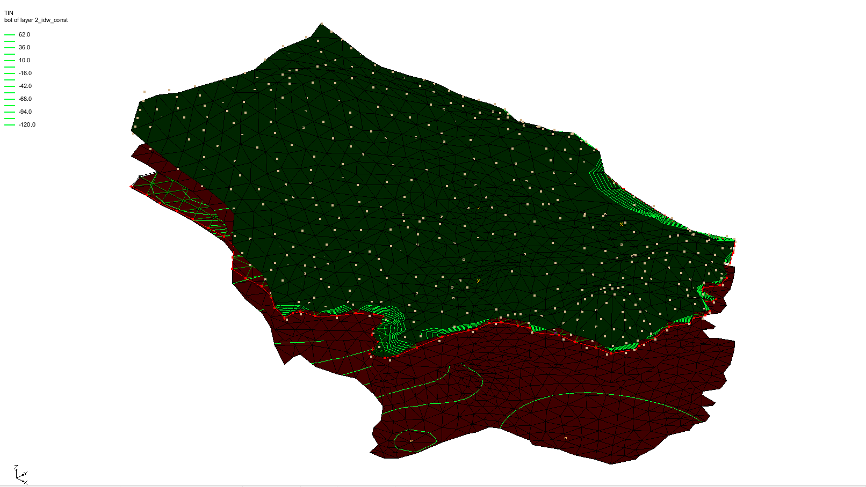

Figure 7 All three TINs with elevations interpolated

## Interpolating the Layer Elevation Data

To construct the 3D mesh using the horizon method, do the following:

1. Click on the “File:TIN Folder.svg TIN Data” folder in the Project Explorer.
2. Select *TINs* | **Horizons → 3D****Mesh…** to bring up the *Horizon Elevations* page of the *Horizons to Mesh* dialog.
3. Click **Next >** to accept the defaults and go to the *Top and Bottom Elevations* page of the *Horizons to Mesh* dialog.
4. In the *Top elevation* section, select *TIN elevations* and then “TIN item – inactive terrain” from the “File:TIN Folder.svg TIN Data” tree below that.
5. In the *Bottom elevation* section, select *TIN elevations* and then “File:TIN Module Icon.svg bottom lower aquifer” from the “File:TIN Folder.svg TIN Data” tree below that.
6. Click **Next >** to go to the *Build Mesh* page of the *Horizons to Mesh* dialog.
7. In the *Meshing options* section, turn on *Refine elements* and *Subdivide material layers*.
8. Below *Refine elements*, select *Refine all elements*.
9. Below *Subdivide material layers*, select *Target layer thickness*.
10. Enter “10.000” in the *Max layer thickness* column of the *Upper Aquifer* row.
11. Enter “20.000” in the *Max layer thickness* column of the *Lower Aquifer* row.
12. Click **Finish** to close the *Horizons to Mesh* dialog.

A 3D mesh will now be generated between the TINs based on the selected options (Figure 8).

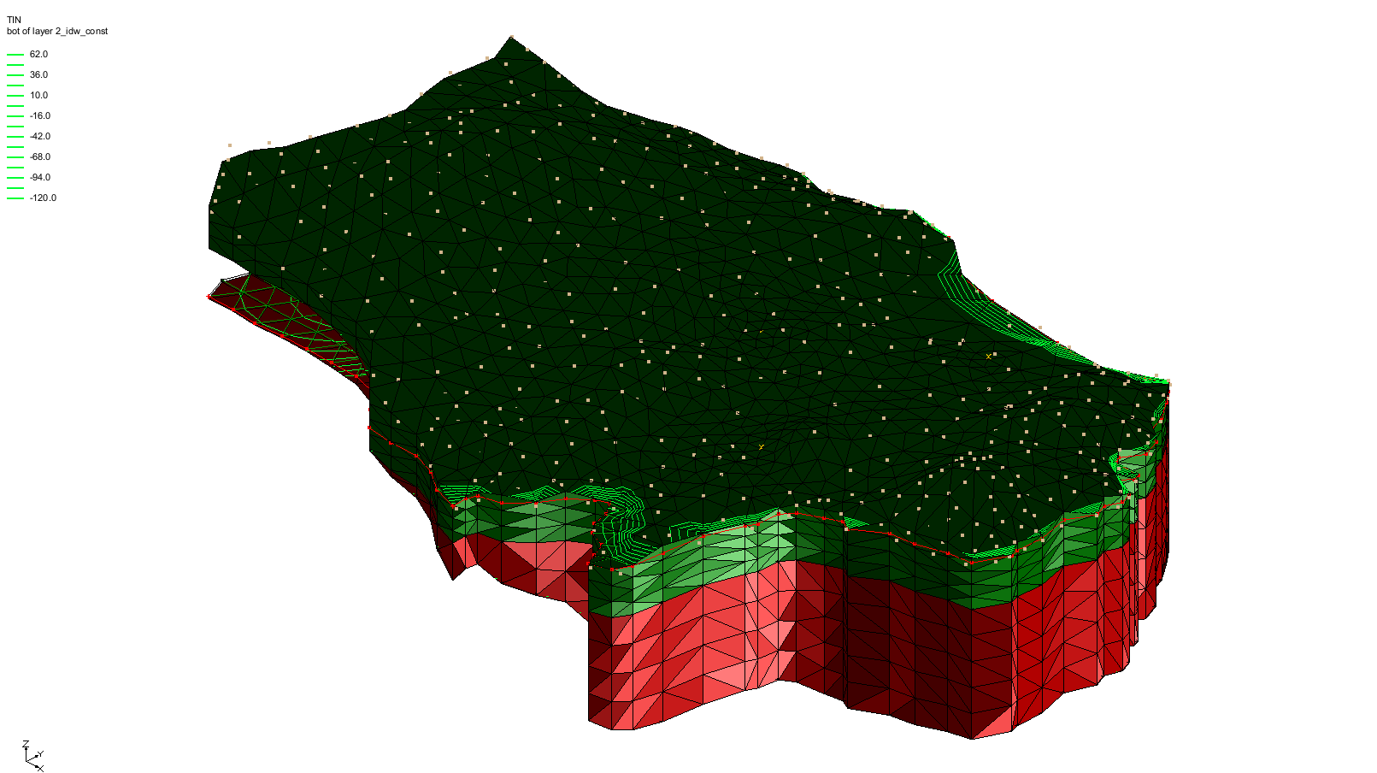

Figure 8 The 3D mesh between the TINs

# Converting the Conceptual Model

Before proceeding, simplify the display by hiding objects that are no longer needed. In the Project Explorer, hide all items except the feature objects and the 3D mesh by following these steps:

1. Turn off “File:TIN Folder.svg TIN Data”, “https://www.xmswiki.com/images/thumb/5/5b/2D_Mesh_Folder.svg/60px-2D_Mesh_Folder.svg.png 2D Mesh Data”, “https://www.xmswiki.com/images/thumb/3/38/2D_Scatter_Folder.svg/60px-2D_Scatter_Folder.svg.png 2D Scatter Data”, and “https://www.xmswiki.com/images/thumb/a/a5/GIS_Folder.svg/60px-GIS_Folder.svg.png GIS Layers”.

Next, convert the conceptual model to the 3D mesh model. This process assigns all boundary conditions based on the data defined on the feature objects.

1. Under “https://www.xmswiki.com/images/thumb/9/9a/3D_Mesh_Folder.svg/60px-3D_Mesh_Folder.svg.png 3D Mesh Data”, right-click “File:3D Mesh Icon.svg mesh (1)” and select **New FEMWATER…** to bring up the *FEMWATER Run Options* dialog.
2. Click **OK** to accept the defaults and close the *FEMWATER Run Options* dialog.
3. Under the “Map Data folder Map Data” folder, right-click on “File:Conceptual Model Icon.svg femmod” and select *Map To*| **FEMWATER** to bring up the *Map → Model* dialog.
4. Click **OK** to accept the defaults and close the *Map → Model* dialog.

Since the model contains only one coverage, the selection at this step does not affect the outcome.

1. A warning dialog may appear saying there is no mesh assigned to a certain part of the model. This has no effect on the model working, so click **OK** to accept the defaults.

A set of symbols should appear indicating that the boundary conditions have been assigned (Figure 9).

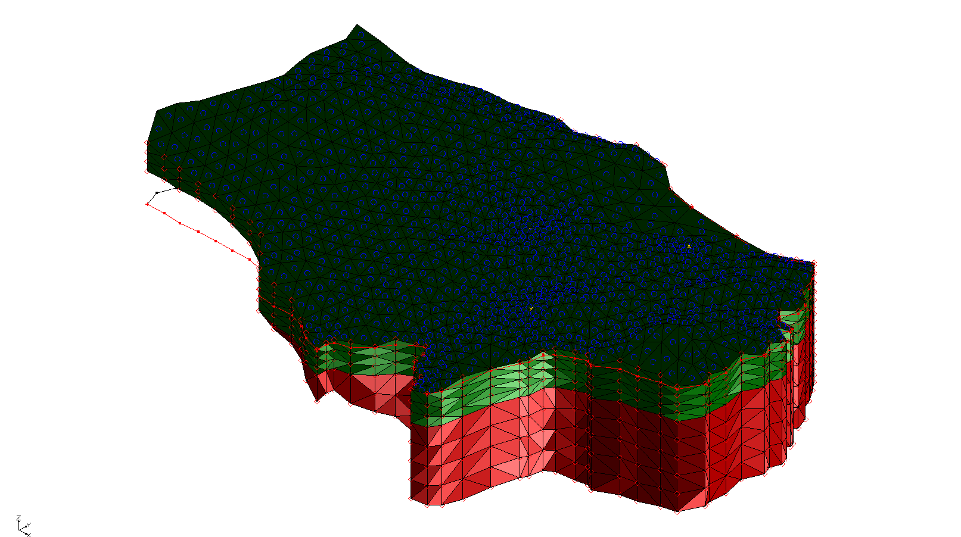

Figure 9 Conceptual model converted to 3D mesh FEMWATER model

# Selecting the Analysis Options

The next step is to switch to the 120px-3D_Mesh_Icon **3D Mesh** module and select which analysis options to use.

## Entering the Run Options

To set up a steady state flow simulation, do the following:

1. Select *FEMWATER |* **Run Options…** to open the *FEMWATER Run Options* dialog.
2. From the *Type of simulation (OP1)* drop-down, select “Flow only (10)”.
3. In the *Solver options (OP2)* section, select “Steady state (0)” from the *Steady-state vs. transient (KSSF)* drop-down.

The problem involves a large, partially saturated region, primarily located in the upper-left corner of the model. Large unsaturated zones can make convergence in FEMWATER more difficult. For such cases, the “Nodal/Nodal” quadrature option is recommended. Although it is less accurate than the default “Gaussian/Gaussian” option, it is more stable.

1. From the *Quadrature (IQUAR)* drop-down, select “Nodal/Nodal (11)”.
2. Click **OK**to close the *FEMWATER Run Options* dialog.

## Setting the Iteration Parameters

Next, adjust the iteration parameters by doing the following:

1. Select *FEMWATER |* **Iteration Parameters…** to bring up the *FEMWATER Iteration Parameters* dialog.
2. For the *Max iterations for non-linear equation*, enter “100”.
3. For the *Max iterations for linear equation*, enter “1000”.
4. For the *Steady-state convergence criterion*, enter “0.003” (m).
5. For the *Transient convergence criterion*, enter “0.003” (m).
6. Click **OK** to close the *FEMWATER Iteration Parameters* dialog.

## Selecting Output Control

The next step is to select the output options. Choose to output only a pressure head file.

1. Select *FEMWATER |* **Output Control…** to open the *FEMWATER Output Control* dialog.
2. In the *Save options (OC4)* section, turn off:
3. *Save flux (.flx) file (2)*
4. *Save nodal moisture content (.mcn) file (3)*
5. *Save velocity (.vel) file (4)*
6. Turn on *Save pressure head (.phd) (1)* file.
7. Click **OK** to close the *FEMWATER Output Control* dialog.

## Defining the Fluid Properties

Finally, define the fluid properties.

1. Select *FEMWATER |* **Fluid Properties…** to open the *FEMWATER Fluid Properties* dialog.

The options in this dialog depend on the selected units. Because this is a steady-state solution, the viscosity and compressibility settings can be ignored.

1. For the *Density of water*, enter “1000.0”.
2. Click **OK** to close the *FEMWATER Fluid Properties* dialog.

# Defining Initial Conditions

Because FEMWATER uses nonlinear equations to model flow in the unsaturated zone, it is more sensitive to initial conditions than saturated flow models such as MODFLOW. If the initial conditions differ significantly from the final head distribution, FEMWATER may converge slowly or fail to converge.

For flow simulations, FEMWATER requires pressure heads as initial conditions. The FEMWATER interface in GMS includes a command to automatically generate these pressure heads from a user-defined water table surface. This surface is represented by scatter points, from which total head values are interpolated to the 3D mesh nodes. The pressure head dataset is then calculated by subtracting node elevations from the total head values.

## Digitizing the Scatter Point Set

To define the initial condition, a small set of points is used at the expected elevation of the computed water table surface. To save time, these points have already been created and are included in the project. For more information on creating scatter points, refer to the “Geostatistics 2D” tutorial.

Before digitizing the points, disable the flux boundary condition display options and enable and adjust the labels for each point by doing the following:

1. Select *FEMWATER |* **BC Display Options…** to open the *Display Options* dialog.

Note that “3D Mesh Data” is already selected in the list on the left.

1. Under the *FEMWATER* tab, turn off *Flux fluid (CB1)*.
2. Select “2D Scatter Data” from the list on the left.
3. In the table below the “Note”, click the large button (not the down arrow) to the right of “startheads” to bring up the *Symbol Attributes* dialog.
4. For the *Size*, enter “10”.
5. Click **OK** to close the *Symbol Attributes* dialog.
6. Turn on *Scatter point scalar values* and click the **123** button to the right to bring up the *Font* dialog.
7. Select “Arial” from the *Font* list.
8. Select “Regular” from the *Font style* list.
9. Select “11” from the *Size* list.
10. Turn on *Fill behind text*.
11. From the *Color* drop-down, select “Specified”.
12. Click the down arrow to the right of *Fill behind text* and select “White” from the list of colors.
13. Click **OK** to close the *Font* dialog.
14. Click **OK** to close the *Display Options* dialog.

Note that all the blue circles disappeared from the top of the 3D Mesh.

To view the scatter point set:

1. Switch to **Plan View** File:Plan View Macro.svg.
2. In the Project Explorer, turn off the “File:2D Mesh Folder.svg 3D Mesh Data” folder.
3. Turn on the “File:2D Scatter Icon.svgstartheads”scatter point set and the “File:GIS Folder.svg GIS Layers” folder.

The scatter points should be located as shown in Figure 10. The value displayed to the right of each point shows its elevation.

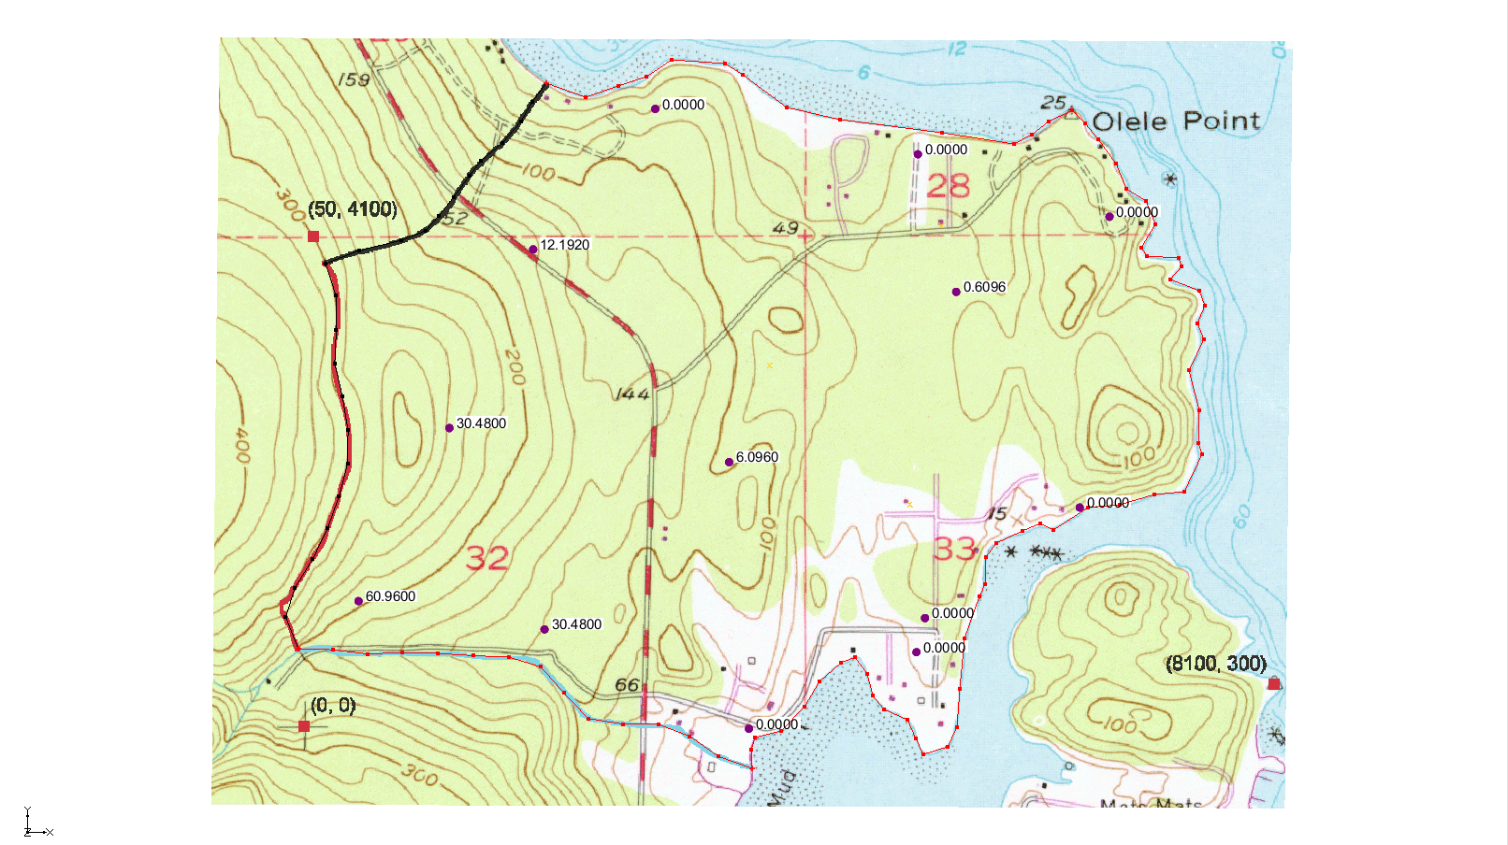

Figure 10 Point locations and elevations

1. When finished viewing the scatter points, turn on the “File:2D Mesh Folder.svg 3D Mesh Data” folder in the Project Explorer.
2. Switch to **Oblique View** File:Oblique View Macro.svg.
3. Click the **Display Options** File:Display Options Macro.svg macro to bring up the *Display Options* dialog.
4. Select “2D Scatter Data” from the list on the left.
5. Turn off *Scatter point scalar values*.
6. Click **OK** to close the *Display Options* dialog.

## Creating the Dataset

A pressure head dataset must now be created and saved to define the initial conditions. GMS will provide the file path to FEMWATER when launching the simulation.

1. Select *FEMWATER |* **Initial Conditions…** to open the *FEMWATER Initial Conditions* dialog.
2. In the *Pressure head (ICH)* section, select *Spatially variable. Read from dataset file (1)*.
3. Click **Generate IC…** to bring up the *Generate Pressure Head Initial Condition* dialog.
4. From the *Active 2D scatter point set* drop-down, select “startheads”.
5. For the *Minimum pressure head*, enter “-60.0”.
6. Click **OK** to close the *Generate Pressure Head Initial Condition* dialog and bring up the *Select name and path of pressure head file* dialog.
7. Enter “starthd.phd” for the *File name*.
8. Select “FEMWATER Pressure Head Files (\*.phd)” from the *Save as type* drop-down.
9. Click **Save** to save the new pressure head file and close the *Select name and path of pressure head file* dialog.
10. Click **OK** to exit the *FEMWATER Initial Conditions* dialog.

# Defining the Material Properties

The final step in model setup is defining the material properties. Each aquifer requires a hydraulic conductivity value and a set of unsaturated zone curves. To define these properties, follow these steps:

1. Select *Edit |* **Materials…** to open the *Materials* dialog.
2. On the *Upper Aquifer* row, enter “3.0” in the *Kxx*, *Kyy*, and *Kzz* columns.
3. With any cell in the *Upper Aquifer* row selected, click **Generate Unsat Curves…** to open the *van Genuchten Curve Generator* dialog.
4. From the *Curve type* drop-down, select “van Genuchten equations”.
5. For *Max. height above water table*, enter “1.8”.
6. Select *Preset parameter values*.
7. From the drop-down next to *Preset parameter values*, select “Silt”.
8. Click **Compute Curves**.

Notice that there are three curves below that button now.

1. Click **OK** to close the *van Genuchten Curve Generator* dialog.
2. On the *Lower Aquifer* row, enter “9.0” in the *Kxx*, *Kyy*, and *Kzz* columns.
3. With any cell in the *Lower Aquifer* row selected, click **Generate Unsat Curves…** to open the *van Genuchten Curve Generator* dialog.
4. Accept the defaults and click **Compute Curves** to generate the three curves.
5. Click **OK**to close the *van Genuchten Curve Generator* dialog.
6. Click **OK** to exit the *Materials* dialog.

# Saving and Running the Model

To save and run the model:

1. **Save**File:Save Macro.svg the project.
2. Select *FEMWATER |* **Run FEMWATER…** to bring up the *FEMWATER* model wrapper dialog.

The FEMWATER window will display information about the progress of the model convergence. The model should converge within a few minutes.

1. When the model converges, turn on *Read solution on exit* and click **Close** to exit the *FEMWATER* model wrapper dialog.

# Viewing the Solution

Once the simulation has finished, the output can then be viewed in several ways, some of which are illustrated below.

## Viewing Head Contours

First, view a color fringe plot.

1. Click the **Display Options** File:Display Options Macro.svg macro to open the *Display Options* dialog.
2. Select “3D Mesh Data” from the list on the left.
3. Under the *3D Mesh* tab, in the lower section, turn on *Contours*.
4. Click the **Options…** button next to *Contours* to open the *Dataset Contour Options – 3D Mesh – pressure\_head* dialog.
5. In the *Contour method* section, select “Single color” from the second drop-down.
6. Click the down arrow in the box next to “Single color” and select “Blue” from the color list.
7. Click **OK** to exit the *Dataset Contour Options – 3D Mesh – pressure\_head* dialog.
8. Under the *FEMWATER* tab, turn off *Specified* *head (DB1)*.
9. Click **OK** to close the *Display Options* dialog.
10. Make certain the “File:3D Mesh Folder.svg 3D Mesh Data” is turned on.
11. Rotate the image using the **Rotate** [](https://www.xmswiki.com/wiki/File:Rotate_Tool.svg) tool.

The Graphics Window should appear similar to Figure 11.

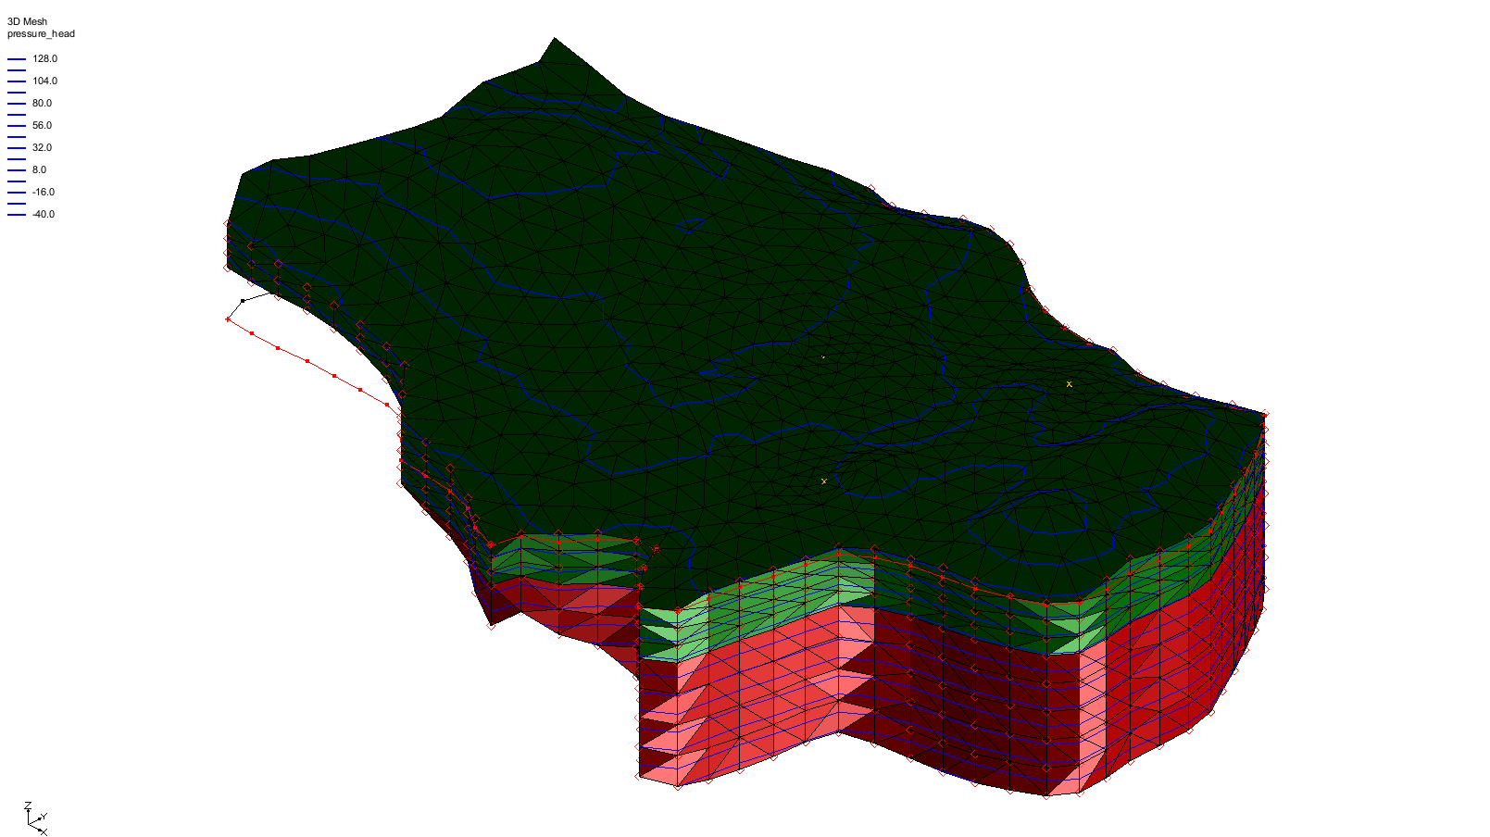

Figure 11 Head contours marked in blue

## Viewing a Water Table Isosurface

Another way to visualize the solution is by generating an isosurface at a pressure head of zero. This surface corresponds to the computed water table. Additionally, by capping the isosurface on the side where the pressure head is greater than zero, a color-shaded image is produced to show pressure variations within the saturated zone.

1. In the Project Explorer, expand the “File:Generic Folder Locked.svg femmod (FEMWATER)” solution folder and select the “File:Dataset Points Active.svg pressure\_head” dataset to make it active.
2. Click the **Display Options** File:Display Options Macro.svg macro to open the *Display Options* dialog.
3. Select “3D Mesh Data” from the list on the left.
4. Under the *3D Mesh* tab, in the upper section, turn off *Element edges*.
5. In the lower section, turn off *Contours* and turn on *Isosurfaces*.
6. Click the **Options…** button to the right of *Isosurfaces* to open the *Isosurface Options* dialog.
7. For the *Number of isosurfaces*, enter “1”.
8. In row *1* of the spreadsheet, enter “0.0” in the *Upper Value* column.
9. In row 2, turn on *Fill Between* to shade the area between “0.0” and the maximum value.
10. In the section on the right, turn on *Isosurface faces* and *Contour specified range*.
11. Enter “0.0” for the *Minimum value* and “140.0” for the *Maximum value*.
12. Click **OK** to close the *Isosurface Options* dialog.
13. Click **OK** to exit the *Display Options* dialog.

The Graphics Window should appear similar to Figure 12.

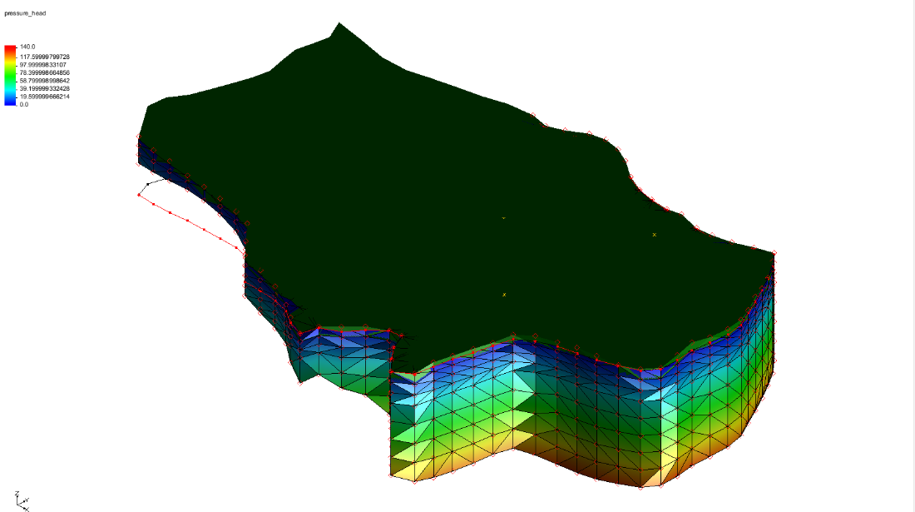

Figure 12 Water table isosurface

## Draping the TIFF Image on the Ground Surface

To illustrate the spatial relationship between the computed water table surface and the ground surface, the TIFF image can be draped over the terrain surface. Start by unhiding the top TIN to make the terrain surface visible.

1. Under the “TIN Data folder TIN Data” folder, turn on and expand the “File:TIN Module Icon.svg terrain” TIN.
2. Select the “File:Dataset Points Active.svg z\_idw\_const” dataset to make it active.

Next, set the option to map the TIFF image to the TIN when shaded.

1. Click the **Display Options** File:Display Options Macro.svg macro to open the *Display Options* dialog.
2. Select “TIN Data” from the list on the left.
3. Under the *TIN* tab, in the top section, turn on *Texture map image to active TIN*.
4. Click **OK** to close the *Display Options* dialog.
5. Make certain that “File:GIS Folder.svg GIS Layers” is turned on.
6. Use the **Rotate** File:Rotate Tool.svg tool to click and drag horizontally to the left side of the screen until the other side of the model is visible (Figure 13).

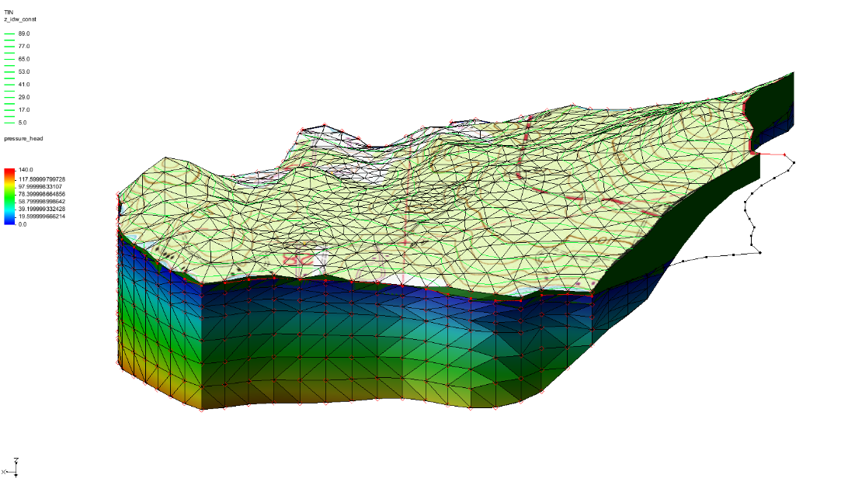

Figure 13 TIFF image draped and the 3D mesh rotated

Finally, try the smooth shade option.

1. Click the **Display Options** File:Display Options Macro.svg macro to open the *Display Options* dialog.
2. Select “Lighting Options” from the list on the left.
3. In the *Surface attributes for all lights* section, turn on *Smooth edges*.
4. Click **OK** to close the *Display Options* dialog.

Notice that the water table isosurface contour is smoother now (Figure 14).

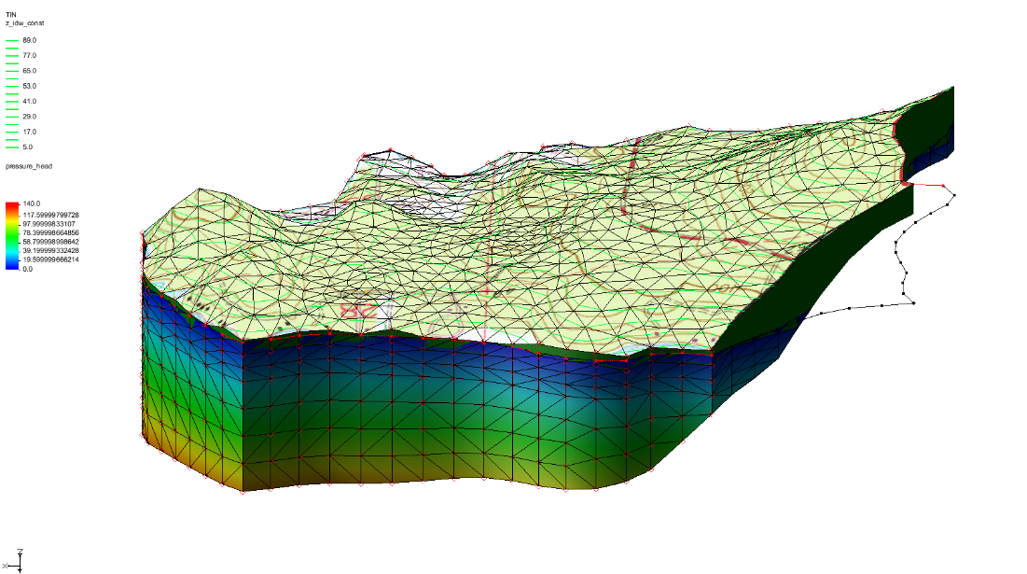

Figure 14 TIFF image draped and the 3D mesh rotated, with smoothing

# Conclusion

This concludes the “FEMWATER – Flow Model” tutorial. The following concepts were discussed and demonstrated:

* FEMWATER is a 3D finite element model that is more complex than MODFLOW (which is a 3D finite difference model)
* How to create a FEMWATER conceptual model
* How to use a conceptual model to create a 3D finite element mesh using a 2D mesh, TINs, and scatter points
* How to set up FEMWATER initial conditions